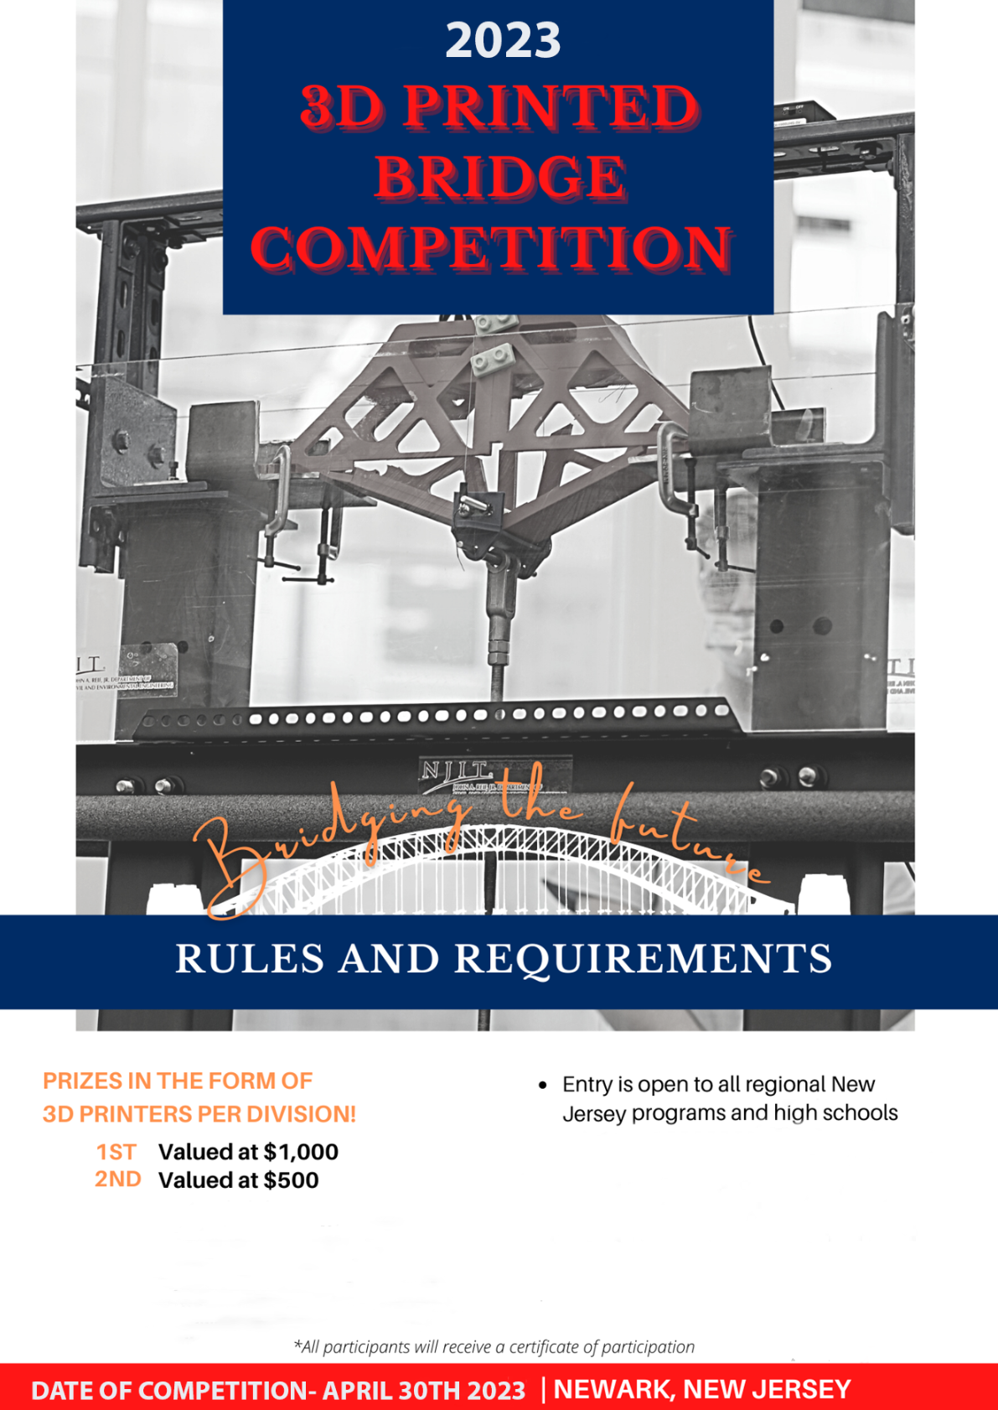

Table of Contents

1. About the Competition 2

2. Participation and Eligibility 3

3. Ethics and Required Conduct 3

4. Safety 3

5. Bridge Dimensions 4

6. Bridge Parts 5

7. Bridge Loading 6

8. Tips 6

9. Scoring 7

a. Vertical Load 7

b. Vertical Stiffness 7

c. Assembly Time 8

d. Aesthetics 8

e. Presentation (Poster Board) 8

11. Timeline 8

12. Awards 8

# About the Competition

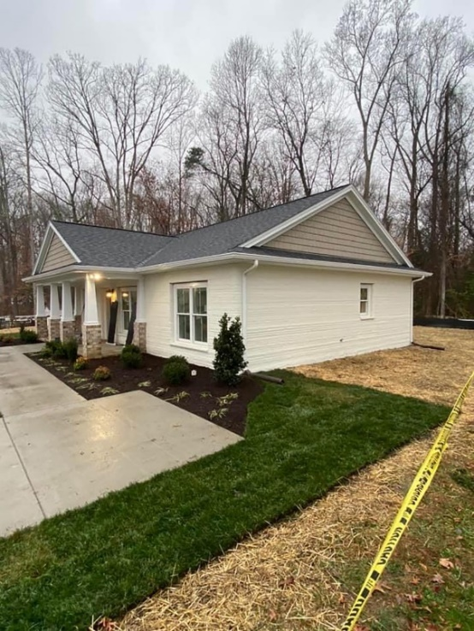Three-dimensional printing (3DP) is an emerging construction technology. 3DP operates by adding sequential layers of material to create a solid object, which saves labor cost, minimizes material waste, and optimizes building time. While 3DP has been used to create prototypes and small-scale models of the built environment for some time, the technology has advanced to the construction of houses and bridges.

The goal of the 3D Bridge Printing Competition is to promote the application of 3D printing technology in the field of civil engineering. For students, the goal is to design an aesthetically-pleasing, strong, and stiff bridge that will take the least amount of assembly time and meets the geometric requirements.

Students must pay attention not only to the design, but also the details of the print, which play a significant role in the shape, tolerances, and strength of the bridge. Students will demonstrate teamwork, organization, analytical skills, and creativity throughout the process of the competition.

Figure 1: [First 3D-printed home](https://www.alquist3d.com/habitat) in the United States, 2021, Williamsburg, VA (Alquist 3D)

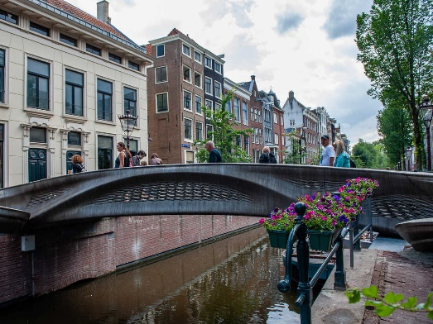

Figure 2: The world’s first [3D printed footbridge](https://www.npr.org/2021/08/27/1031253065/first-3d-printed-steel-bridge-in-europe), 2021, Amsterdam, the Netherlands (Ana Fernandez/SOPA Images/LightRocket via Getty)

# Participation and Eligibility

1. Team Requirements

For each institution, only one team of 3 to 5 members and one advisor may participate.

1. Registration

Please fill out the [initial registration form](https://forms.gle/xFTam2TSWXBH3v7p8) to indicate your interest in participating as soon as possible. On 17 February 2023, the [team information packet](https://drive.google.com/file/d/18TUoE5SIj2nzwpjh8Fxdi2BucDMIBuyZ/view?usp=sharing) to officially register your team is due along with the $150 registration fee. For questions, please contact Kori Hodges  at [kori.hodges@njit.edu](mailto:kori.hodges@njit.edu) or call 973-596-2444.

# Ethics and Required Conduct

This competition is to be conducted with the highest regard for ethical responsibility per [ASCE’s Code of Ethics.](https://www.asce.org/career-growth/ethics/code-of-ethics) All participants shall act professionally and respectfully at all times. Failure to act appropriately may result in sanctions, disqualifications, and loss of invitations to future competitions. The inappropriate use of language, alcohol, or materials, uncooperativeness, and general unprofessional or unethical behavior will not be tolerated.

# Safety

Participants acknowledge that there are risks to be considered when creating and testing 3D printed structures. Bridges should be printed in a well-ventilated area, and care should be taken to avoid injury when working with a 3D printer. Connections that are 3D printed are prone to some error, and participants are encouraged to print tests of connections to account for tolerancing issues. If any parts need to be filed or cut, participants need to ensure proper caution as well as hand and eye protection are used. In the testing of bridges, participants must be cognizant of PLA’s brittle nature. Bridges can fail suddenly and even explosively. Only participants actively involved with the testing of bridges should be near the loading apparatus and should wear eye protection as well as work gloves if handling the bridge or the loading apparatus during testing. Participants should consistently use the safety features included in the loading apparatus (e.g., plexiglass shield).

All participants are responsible for complying with all campus protocols and procedures including but not limited to COVID-19 guidelines related to in-person meetings, masking, social distancing, etc., at all times in connection with planning, preparation, or participation in the competition. Given the continually changing environment surrounding COVID-19, virtual competition provisions may be provided.

# Bridge Dimensions

The bridge must span an open length of 18 inches (457 mm). The total bridge length can be no longer than 22 inches (559 mm) for a 2-inch (51 mm) bearing support on each side, no taller than 8 inches (203 mm), and no wider than 6 inches (152 mm). The bridge structure can extend no more than 2.5 inches (64 mm) below the piers and no more than 6 inches (152 mm) above the piers. The clear volume through the bridge must be greater than 3 inches by 3 inches (76 mm x 76 mm) area through its entire length to allow a test vehicle of those dimensions to pass easily through. This volume must not be interrupted by structural elements. The clear volume should be 1.5 inches (38 mm) above the piers and should be underlain by a deck for a vehicle to pass over (see Figure 3 and Figure 4).



Figure : Elevation View of Bridge



Figure : Section View of Bridge

# Bridge Parts

* 1. All parts must be printed with 100% Plain PLA (Polylactic acid). No other material fill allowed.
  2. The maximum allowed bridge weight is 17.6 ounces (500 grams).
  3. All parts together must fit into a box 8.7 in. (220 mm) wide, 8.7 in. (220 mm) long, and 6.5 in. (165 mm) high.
  4. Only mechanical connections (No Adhesive allowed).
  5. No unextruded filament may be used in the bridge.
  6. There is no limit on testing of parts and bridges before competition.

# Bridge Loading

Bridges will be placed on the load platforms (bridge piers) and centered. Figure 5 shows the load frame, including the platforms that will serve as the bridge piers. The loading saddle (aluminum piece in the middle of Figure 5) is hung over the center span of the bridge by a 5/8” bolt (see Figure 6), and weights in 22 lb (10 kg) increments will be successively placed on the platform attached to the load saddle by a clevis rod. Deflection will be measured by string potentiometers following each applied load, with a measurement at a load corresponding to 50 lb used to determine bridge stiffness. Loads will be applied until bridge failure (see Figure 6).

Figure 5: Loading frame with load saddle

Figure : Bridge loaded to failure

# Tips

* Make sure that all parts you design can fit within the bed of the 3D printer you are using.
* 3D printed sockets tend to be slightly smaller than designed, so be sure to adjust your designs to accommodate shrinkage as the filament cools during printing. Test printing small samples of the connections will help you calibrate connection fits with your printer/filament.
* Check the fits of all components before the day of the competition as much as possible.
* Ensure the length and width of your bridge match the specifications so that your bridge qualifies and can be tested.
* It is important to engage the entire superstructure in supporting the load—not just the bridge deck or the point at which the load is applied, so make sure the deck is well connected to the superstructure.
* Be sure to reinforce the area where the 5/8” bolt will rest on the centerline of the bridge deck during loading.

# 9. Scoring

There are five weighted metrics which will be added in aggregate to determine the teams’ overall scores. The metrics and their weighted contribution are shown below in Table 1. In addition to receiving a single score which will be the basis for winning 1st, 2nd, and 3rd place overall, the top two teams in each category will be separately recognized for their superior performance in that category.

Adherence to the rules is crucial to ensuring a fair competition. Teams will be subject to deductions determined by the judges for deviations from the rules as they relate to each category. Information on each category is detailed in the following sections.

Qualitative categories (Aesthetics & Presentation) will be determined by a simple ranking system, and quantitative categories (Load, Stiffness, Assembly Time) will be based on a proportional ranking system. The last-place team in a given category will receive 1 point, and the first-place team will receive the full points (e.g., 50 points for highest vertical load). The remaining teams will be allocated points based on linear interpolation. For example, if four teams compete and have vertical loads of 260, 160, 140, and 100 lb., the first team will receive 50 points, the second team will receive 19.4 points, the third team will receive 13.25 points, and, and the fourth team will receive 1 point.

Table : Overall Category Score Weighting

|  |  |  |  |  |
| --- | --- | --- | --- | --- |
| **Vertical Load** | **Vertical Stiffness** | **Assembly Time** | **Aesthetics** | **Presentation** |
| 50 | 20 | 10 | 10 | 10 |

### Vertical Load

* + 1. The load will be applied vertically at center span, with maximum points awarded to the bridge supporting the largest load at failure.

### Vertical Stiffness

* + 1. Stiffness will be judged at the same load for all bridges (50 lb.) by measuring the vertical deflection at center span.

### Assembly Time

* + 1. Each team is to have one or more representatives work together to assemble the bridge.
    2. The time is multiplied by the number of members working on assembly.
    3. Teams taking 15 minutes or longer to assemble will receive the minimum score in this category.

### Aesthetics

* + 1. Include information about the design inspiration in the presentation.
    2. Aesthetics will be based on bridge geometry, not color.

### Presentation (Poster Board)

* + 1. Each team will present in five minutes or less a poster board (24 inches x 36 inches) outlining:
       1. Team composition
       2. Design inspiration for bridge
       3. 3D images of bridge
       4. Print details
    2. Judges will rank presentations based on:
       1. Readability of poster
       2. Aesthetics of poster
       3. Adherence to the 5-minute time limit
       4. Presentation mechanics (projection, pace, facing judges, etc.)

# 11. Timeline

* Town Hall* - Friday, January 13 at 12 pm – Webex
* Town Hall* - Friday, February 17 at 12 pm - Webex
* Submit Bridge Design - Friday, March 31 to william.h.pennock@njit.edu
* Competition Date - Sunday, April 30 | 8:00 AM - 4:00 PM | NJIT Campus Center

# 12. Awards

* 1. Recognition awards will be awarded for categories (1st and 2nd):
     1. Largest Load,
     2. Fastest Assembly Time,
     3. Stiffest Bridge,
     4. Best Aesthetics, and
     5. Best Presentation
  2. The team that gets the highest overall score will be awarded the best overall award.
  3. The teams that get the second and third highest overall scores will be awarded second and third place.